Creative Lounge Film Interview
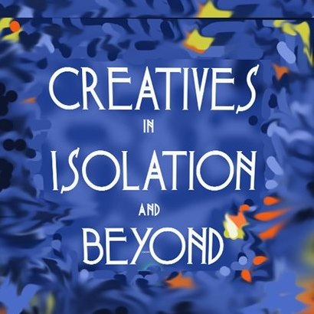

The Creative Isolation Blog
https://www.facebook.com/CREATIVESISOLATION/
http://www.creativeisolation.com.au (live July 5th)
https://www.instagram.com/theisolationblog
creativeisolationblog@iinet.net.au
PROUDLY SPONSORED BY THE ARMADALE CITY COUNCIL

Introduction
Thank you for agreeing to be part of this project: ‘‘Breaking down the Winter Moments and Making Art Instead’ (Creatives during Isolation and Beyond). This is a supported isolation project by my City Council, Armadale, based in Western Australia. However, our aim is to eventually support people all over the world.

Some people are really struggling with ‘creative block’ at the moment; some for a short time, others for ages.
People may be directly affected due to being unwell or a gradual feeling of unable to work on their craft, which eventually becomes so ingrained fear has set in. The degree of impact could be severe or mild. The block may have started during the COVID 19 pandemic, before then and at times, we don’t even know when it began. All we know is it hurts as it feels the ability to work in areas they love will never return.

Your Involvement
As you may be aware, your wonderful self has been invited to be in our Creative Lounge on the blog/webpage as you have indicated that you maybe able to share a story, some thoughts or experience that maybe able to assist someone else.

Your input, creative practice and support to others will be seen on the webpage ‘The Creative Isolation Blog’ together on social media. It is totally up to you how you are represented and how much information you decide to give. There is the chance to be professionally filmed or to just answer some questions in a form that will then be placed on the page.

Film Component
If you live in WA and agreed to a filmed interview, we would very much like to take shots of you in your creative space, or a place that assists you in your creative process. However you want to be photographed and represented is totally up to you. Allow for up two hours, just so we can ensure we have enough content and shots to showcase your skills. It is up to you if you are a performer/singer/dancer if some of your craft is part of the film.

My partner, Andrew is one of the Directors of JAK Films and will be taking still shots as well as filming my interview with you. We are both pretty easy going and the questions are very conversational, relaxed and not something to be concerned about. Andrew will edit the footage to ensure you are represented in a way you are totally happy with. You are more than welcome to view the edited version before it is placed on the page. The footage is linked to the project’s You Tube Channel and the link is placed on the webpage together with an image of you, or whatever you wish to share.

Pre-interview

It would be wonderful and if you are happy to, can you send through whatever you would like to represent yourself together with the link to the interview? On the next page is an area to give me some information in preparation for your interview.

We have a ‘Creative Gallery’; feel free to send through images, links to merchandise, to music videos or performances. If it is okay, we would like to represent you visually with a photo you provide of yourself, together with your webpage/social media or even email if you prefer. Again, this is totally up to you.

How much you want to share, divulge and become involved is up to you. Some of the artists may work/perform in your genre, type of craft, and may ask for contact or the possibility to be further contacted with you. We are happy to be the in-betweens so you don’t get direct contact, or you can begin contact, or none at all. That’s up to you, no pressure at all.

Once again, we want to thank you for your support. No rush in filling it in, just before your interview would be great. . Feel free to put whatever you like, as much as you like, or as little. How you get represented is up to you.

Please save this document as creativelounge and then your surname. Save either in word, page so that any words/dialogue images can be transferred easily to the webpage.

You will be given the option to edit any content pertaining to you on the webpage at any time. You can also ask for an update if your circumstances change.

Thank you once again for taking part in this project

Warm regards

Julie Fearns-Pheasant
Creative Isolation and Beyond Project.
creativeisolationblog@iinet.net.au

I have created this in Word format for you so it can be typed into. Please let me know if you have any issues at all.

Name:

Practice/Business name:

Genre/s of art practice:

Location : (State, Country etc.)
Social Media links (includes webpage) : (Please note if these are allowed to be used/advertised on the webpage)

Contact address/phone number/email (not for publication, only for the projects’ data-base)

Short biography you would like to be the introduction to who you are, any highlights in your career as a creative you would like to share?

These may be some of the questions, or things to think about before your interview.

Could you describe a bit about your creative process , your favourite themes, mediums/genres? Anything you would like to share about what inspires you to keep creating, believing in your abilities?

Have you ever experienced a creative block or time in your career as a creative where things were difficult that made it difficult to practice your craft? Would you mind sharing that in some way? How did it affect you? How did you move on from that?

What would you advise someone in a creative block/to move on with their craft to do? What are some steps, some words of encouragement you could give them? (Or even a source/book/person/etc to look towards?)

Would you be up to being a mentor or provide support to another creative? (This is not compulsory)

If so, in what way? What type of creative?

If so, how would you like communication to go ahead? (Through me only? Initially etc.)

Could you please insert a jpeg image of yourself, a few images of your work or practice that you would not mind sharing, with a brief description of what each image is? Medium, location or event (if you are performing etc) If you wish to share a link to a particular event, feel free and we will share it with your permission)

(Feel free to attach to an email or use a couple of pages here)

